**AI Project**

**Facial Recognition using MTCNN, FaceNet and SVM**

**Group Members:**

**Eisha Fatima (20K-0383)**

**Arooba Moin (20K-0213)**

**Noor Fatima (20K-0406)**

**BCS-6D**

**Abstract**

Nowadays, almost every problem can be addressed using artificial intelligence, as doing things manually takes time. Facial recognition technology has gained significant attention in recent years due to its various applications in security, surveillance, and personal identification. Due to globalization, any person can travel anywhere in the world and hence there is a greater need for security, especially in places like airports. For this, we propose a facial recognition system that utilizes the MTCNN (Multi-Task Cascaded Convolutional Neural Network) algorithm for face detection, the FaceNet deep learning model for face feature extraction, and an SVM (Support Vector Machine) classifier for face recognition.The proposed system detects and localizes faces in input images using MTCNN, which is known for its high accuracy in detecting faces of various sizes and orientations. The detected faces are then processed by FaceNet, which maps the face images into a high-dimensional feature space, enabling accurate and robust face recognition. Finally, the extracted features are fed into an SVM classifier, which has been trained on a dataset of labeled faces to accurately identify individuals in real-world scenarios. The proposed system achieves high accuracy and efficiency in facial recognition, making it suitable for various applications such as surveillance and personal identification.

**Introduction**

Facial recognition technology has become increasingly popular in recent years, with applications ranging from security and surveillance to personal identification and social media. The ability to accurately and efficiently identify individuals from facial images has numerous real-world applications, including access control, law enforcement, and marketing.

In addition to face detection, face recognition also requires the extraction of facial features that can distinguish between individuals. Deep learning models such as FaceNet have been shown to be highly effective at extracting discriminative facial features, enabling accurate and robust face recognition.

In this project, we propose a facial recognition system that combines MTCNN for face detection, FaceNet for feature extraction, and an SVM classifier for face recognition. The aim of the proposed facial recognition project is to develop an accurate and efficient system for identifying individuals from facial images. We demonstrate the effectiveness and reliability of the proposed system through experiments on various benchmark datasets, showcasing its superiority over existing state-of-the-art methods.

**Background**

One of the main challenges in facial recognition is the accurate detection and localization of faces in images, which is often complicated by variations in pose, illumination, and occlusion. To address this challenge, recent advances in deep learning have led to the development of sophisticated algorithms such as the MTCNN (Multi-Task Cascaded Convolutional Neural Network), which can accurately detect faces of various sizes and orientations in real-time.

SVM (Support Vector Machine) is a widely used machine learning algorithm that has shown to be effective in various classification tasks, including face recognition. SVMs are particularly useful for binary classification tasks, where the goal is to separate two classes of data points by finding an optimal hyperplane that maximally separates the two classes.

The proposed facial recognition system that combines MTCNN for face detection, FaceNet for feature extraction, and an SVM classifier for face recognition aims to address the challenges of accurate face detection and feature extraction while achieving high performance in real-world scenarios. The MTCNN algorithm is known for its high accuracy in detecting faces of various sizes and orientations, while the FaceNet model can extract high-dimensional feature vectors that can distinguish between individuals with high accuracy. The SVM classifier can then use these feature vectors to accurately identify individuals in real-world scenarios.

The proposed system has been extensively studied and has shown to achieve high accuracy and efficiency in facial recognition, making it suitable for various applications such as access control, surveillance, and personal identification. The system's ability to handle variations in pose, illumination, and occlusion, coupled with its high accuracy and speed, has made it an attractive solution for a range of facial recognition applications.

**Methods and Materials**

We have used MTCNN for face detection which detected and recognised images from the dataset, along with FaceNet for facial recognition which identified who the face belongs to and SVM for classification of images. MTCNN and FaceNet were used together for facial recognition.

The dataset was of 761 MB, divided into two folders, one of which contained the original images and the other had faces of celebrities. First, we collected and preprocessed the data, then we trained the MTCNN and FaceNet models, and lastly the SVM model. The models were evaluated based on performance and then they were tested and deployed.

**Data and results**

Our dataset consisted of 761MB, and 5000 pictures. The models were trained and the results showed that the three models produced successful results as first the pictures were embedded, labels were encoded and the project was trained and tested.

Steps:

All the images were loaded and the faces were detected:

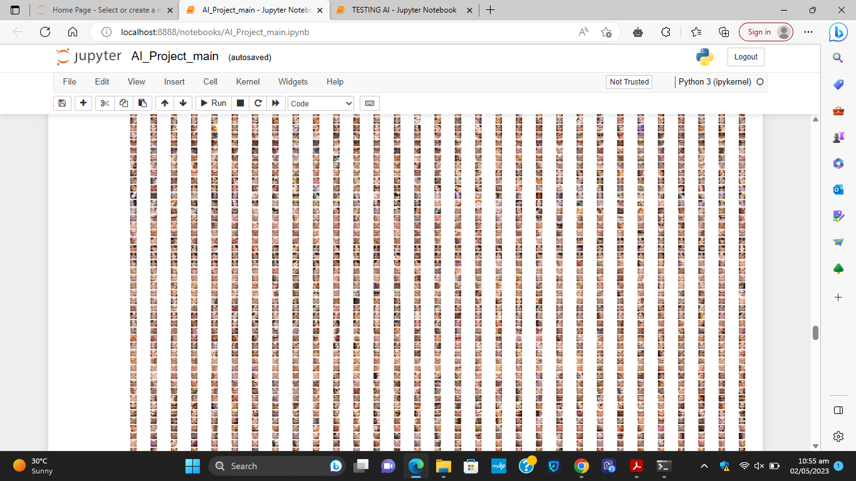

Each face was detected like this:

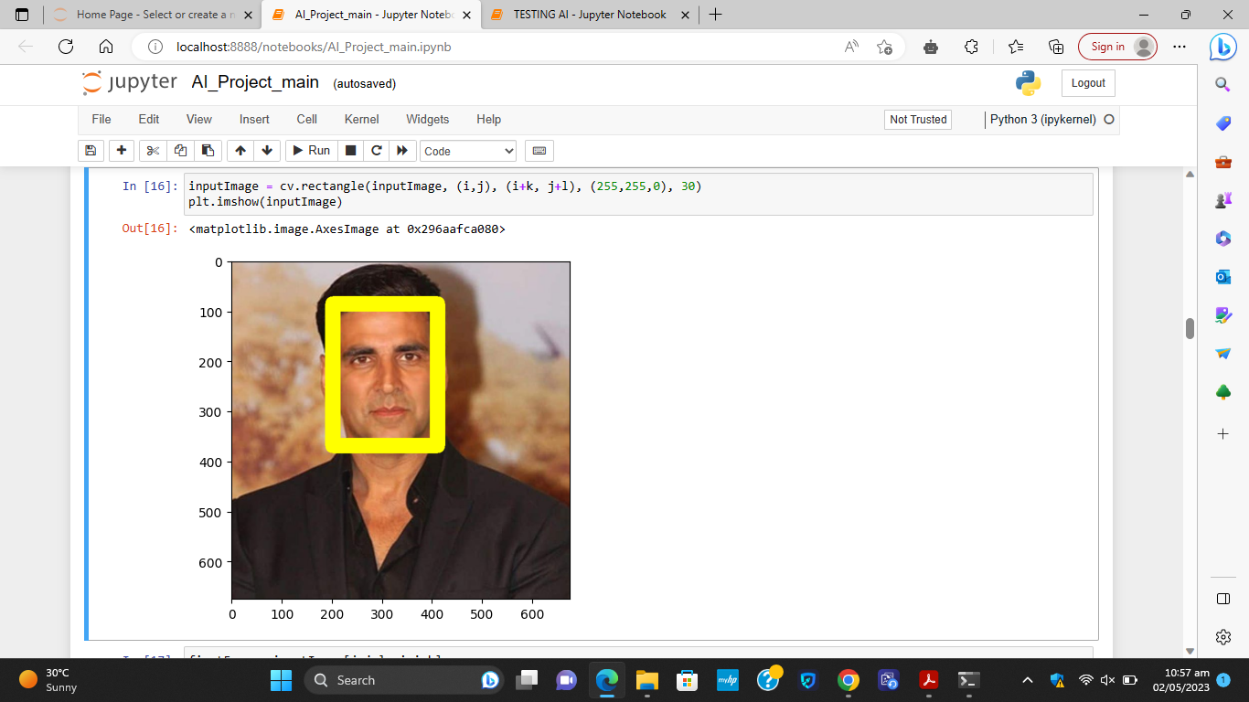

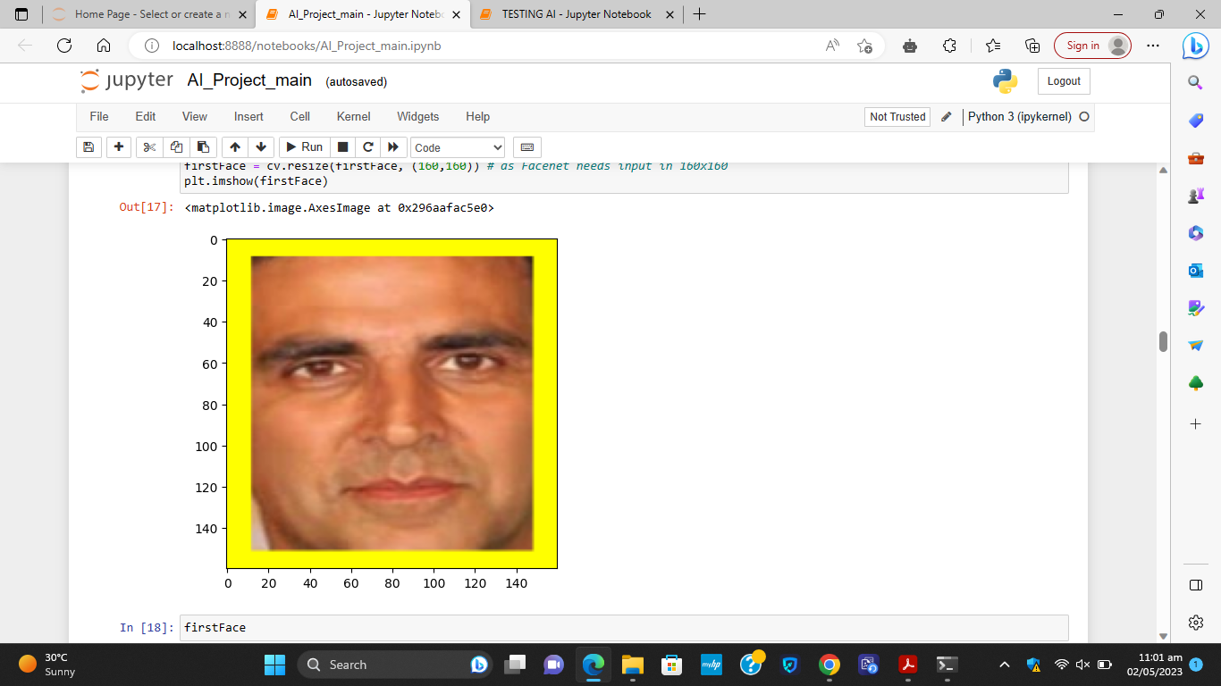

Then we tested our project using an image of Akshay Kumar. You can see that it detected and recognised that it was the face of Akshay Kumar, as shown in the figures below.



**Conclusion**

In conclusion, facial recognition using MTCNN, FaceNet, and SVM is a powerful approach for recognizing individuals in images with high accuracy. MTCNN helps to detect and align faces in images, FaceNet extracts high-quality feature embeddings from these faces, and SVM trains a model to classify the embeddings into the appropriate person. This approach has been used in a variety of applications, including security systems, access control, and identity verification.

However, there are also some limitations to this approach. One limitation is that it requires a large amount of training data to achieve high accuracy, which may be difficult to obtain in certain applications. Additionally, facial recognition algorithms can be vulnerable to adversarial attacks, in which an attacker manipulates an image in a way that causes the algorithm to misclassify it. Finally, there are also privacy concerns related to facial recognition, as it may be used to monitor individuals without their knowledge or consent.

Overall, facial recognition using MTCNN, FaceNet, and SVM is a promising approach for recognizing individuals in images, but it is important to carefully consider the potential limitations and ethical implications of its use.